Siderosis bulbi resulting from an intraocular metalic foreign body : Case Report

Abstract
Siderosis bulbi is a sight-threatening condition characterized by a pigmentary and degenerative change in the eye that follows the intra-ocular retention of a foreign body containing iron. The main cause of ocular siderosis is penetrating trauma mostly by hammering a steel object without or with poor eye protection. Herein, we report a case of siderosis bulbi after penetrating trauma that was lately treated with vitrectomy to remove the foreign body, and despite treatment resulted in ocular globe atrophy.
Keywords: Retina; vitrectomy; wounds and injuries;optic atrophy; night blindness

Resumo
Siderosis ocular e caracterizada por alteracoes pigmentares e degenerativas oculares causada por retencao de corpo estranho intra-ocular contendo ferro, que pode levar a perda da visao. A principal causa de siderosis ocular e o trauma penetrante, causado principalmente por martelar objetos de metal com pouca ou nenhuma proteção ocular. Relatamos o caso de um paciente com siderosis ocular causado por trauma penetrante, que foi tratado tardiamente com vitrectomia para remoção do corpo estranho e apesar do tratamento evoluiu com atrofia do globo ocular.
Palavras chaves: Retina; vitrectomia; ferimentos e lesões, atrofia óptica; cegueira noturna.

Introduction

Ocular siderosis is the reaction of the eye to a retained iron foreing body. The iron accumulate particulary in the epithelial structures, such as dilatador muscleof the iris, nonpigmentated ciliary epithelium, lens epithelium, retinal pigment epithelium and the retina. The most commom cause of eye siderosis is the perforation of the eye by iron fragments usually by grinding, drilling, or striking metal in the setting of poor eye protection.¹ High-velocity metal fragments could penetrate the cornea or sclera without a visible entry site due to their small size and to the corneal self-seal wounds. Patients tipically present with persistent ocular irritation and redness with or without change in visual acuity². If iron foreing body is left in the eye it can cause the sideroris, which is characterized by a rust-colored corneal stroma, greenish-brown iris discoloration, yellow cataract with brown deposits on the anterior capsule, pigmentary retinal degeneration, optic disc swelling/hyperemia and optic atrophy. ³ The removal of the retained foreing body is the mainstay of the treatment.

Case report

A 46 year-old man referred low progressive visual acuity for 08 months in the right eye, triggered by penetrating trauma with metallic material in his right eye. He was hammering a steel object without wearing safety glasses.
On examination, he had visual acuity of light perception in the right eye and 20/25 in the left eye. On slit-lamp examination, was observed a yellow cataract with brown deposits on the anterior capsule, presence of brownish pigments in epithelium and corneal stroma, opacity of anterior chamber with siderotic pigments, fixed mydriasis and iris heterochromia (Figure1) . Intraocular pressure was 04 and 12mmHg in the right and left eye respectively. Fundoscopy was impractical in the right eye and was normal in the left eye. A B-Scan ultrasound of the right eye showed silent vitreous and retina applied. The orbits X-Ray showed linear metallic artifact in the projection of the right orbtit cavity(Figure 2)
Pars plana vitrectomy and catartact surgery was peformed for removal of metallic material (Figure 3). Three months after the removal of the iron foreing body visual acuity dropped to no light perception in the right eye.

Discussion
Siderosis bulbi is sight –threatening complication of a retained iron –containing intraocular foreign body and may occur from 18 days to 08 years after ocular trauma.⁴ Classical findings are characterized by iris heterochromia , pupilary mydriasis, cataract formation, retinal pigmentary degeneration and occasionally secondary glaucoma.⁵ These findings are caused by the dissociation of metallic foreign body resulting in iron deposits in the epithelial structures, such as the dilator muscle of the iris, lens epithelium , nonpigmented ciliary epithelium, retinal pigment epithelium and retina, which cause toxic effects resulting in cells death⁶. Intraocular metal foreign bodies commonly occur in the setting of construction, machining, or auto repair. Hammering steel is the commonest cause of injury.⁷ The history is usually of striking metal in the setting of no or poor eye protection. Patients typically showed ocular irritation and redness, with or without alterations in visual acuity.² The diagnosis is usually made by examination slit lamp, which can detect foreign body in lens, anterior chamber and by a dilated fundus examination, when it is possible. If the foreign body is not clinically evident, orbits computed tomography, ultrasonography B-Scan can be performed. A plain orbital X-ray is the recommended imaging for detection of an intraocular foreign body, but if negative a computadorized tomography scan is then performed.⁸ Magnetic resonance imaging is very sensitive in detecting foreign bodies, however, is limited because of the threat of a magnetic object’s movement during the test, which can cause more damage.³ The most common symptoms are nyctalopia, constricted visual field, decreased vision and eletroretinographic changes.
Pars plana vitrectomy is the mainstay treatment of intraocular foreign bodies located posteriorly. Extracapsular cataract extraction using phacoemulsification or nuclear expression with posterior chamber intraocular lens implantation may be the procedure of choice for visual rehabilitation of eyes with siderotic cataract.
Loss of vision is usually owing to retinal degeneration. The disappearance of symptoms and signs of siderosis following removal of the foreign body has been reported, however, if the iron foreign body is left in the eye, or even is removed it may cause permanent visual loss⁹. Moreover, complications following surgery are rather common as postoperative retinal detachment and proliferative vitreoretinopathy. The mass of the intraocular foreign body is a prognostic factor due to its higher kinetic energy which can cause more damage to the eye tissues.¹⁰
Suspicion of retained intra-ocular foreign body must be investigated in all patients with suspicion of penetrating trauma. The removal of the intra-ocular foreign body should be strongly recommended to avoid the development of ocular siderosis. Although the foreign body is most often surgically removed, in some instances it may be left within the eye. In these cases, close follow-up is recommended.

References
1 - Talamo, J. H., Topping, T. M., Maumenee, A. E., & Green, W. R. (1985). Ultrastructural studies of cornea, iris and lens in a case of siderosis bulbi.Ophthalmology, 92(12), 1675-1680.
2- Benson, W. B. (2011). The incidence of intraocular foreign bodies and other intraocular findings in patients with corneal metal foreign bodies. Evidence-Based Ophthalmology,12(2), 76-77.
3- Mester, V., & Kuhn, F. (2002). Intraocular foreign bodies. Ophthalmology Clinics of North America, 15(2), 235-242.
4 - Sneed, S. R., & Weingeist, T. A. (1990). Management of siderosis bulbi due to a retained ironcontaining intraocular foreign body. Ophthalmology, 97(3), 375-379.
5- O’Duffy, D., & Salmon, J. F. (1999). Siderosis bulbi resulting from an intralenticular foreign body. American journal of ophthalmology, 127(2), 218-219.
6 - Gerkowicz, K., Prost, M., & Wawrzyniak, M. (1985). Experimental ocular siderosis after extrabulbar administration of iron. British journal of ophthalmology, 69(2), 149-153.
7- Ballantyne, J. F. (1954). Siderosis bulbi. The British journal of ophthalmology,38(12), 727.
8. Lapira, M., Karl, D., & Murgatroyd, H. (2014). Siderosis bulbi as a consequence of a missed intraocular foreign body. BMJ case reports, 2014, bcr2013202904.
9. Zhu, L., Shen, P., Lu, H., Du, C., Shen, J., & Gu, Y. (2015). Ocular trauma score in siderosis bulbi with retained intraocular foreign body. Medicine, 94(39).
10. Loporchio, D., Mukkamala, L., Gorukanti, K., Zarbin, M., Langer, P., & Bhagat, N. (2016). Intraocular foreign bodies: A review. Survey of ophthalmology.

Figures ( source prepared by authors)
Legendes
Figure 1. observed a yellow cataract with brown deposits on the anterior capsule, presence of brownish pigments in epithelium and corneal stroma, opacity of anterior chamber with siderotic pigments, fixed mydriasis and iris heterochromia
Figure 2. The orbits X-Ray showed linear metallic artifact in the projection of the right orbtit cavity
Figure 3. The removed intraocular metalic foreing body.
Figure 1.
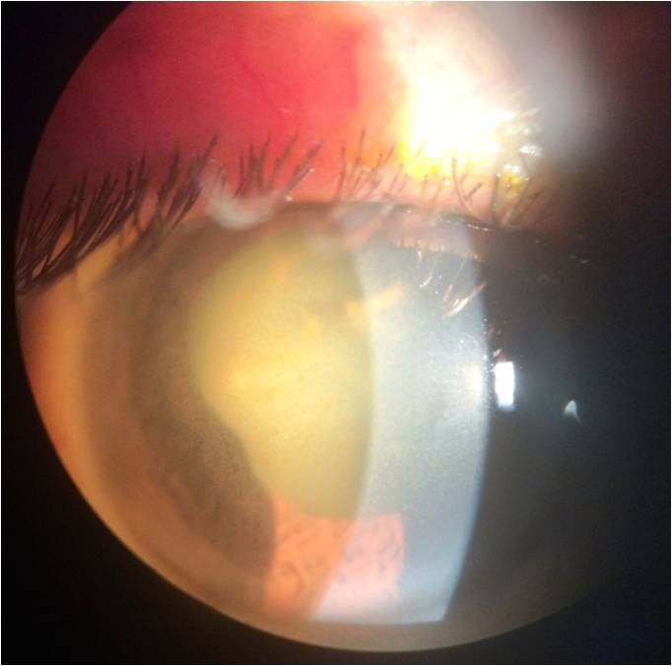

Figure 2.
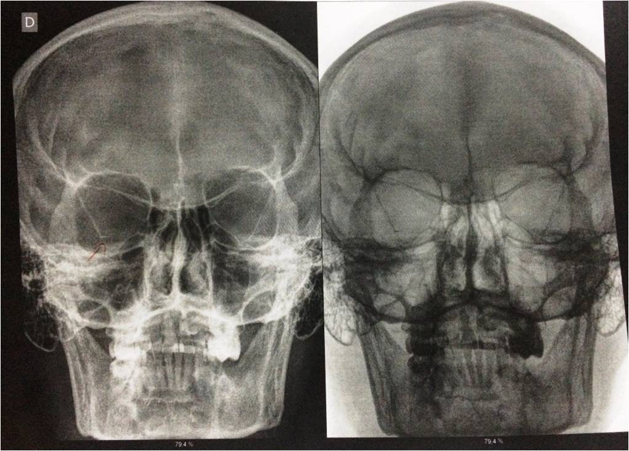

Figure 3.
